**Lesson 29-31:**

***Tokenization*** is the process of breaking down a text or a sequence of characters into smaller units called tokens. These tokens can be words, subwords, characters, or even phrases depending on the granularity of the tokenization.

The goal of tokenization is to create meaningful units that can be used for further analysis, such as natural language processing or machine learning tasks. These tokens serve as the basic building blocks for language processing algorithms.

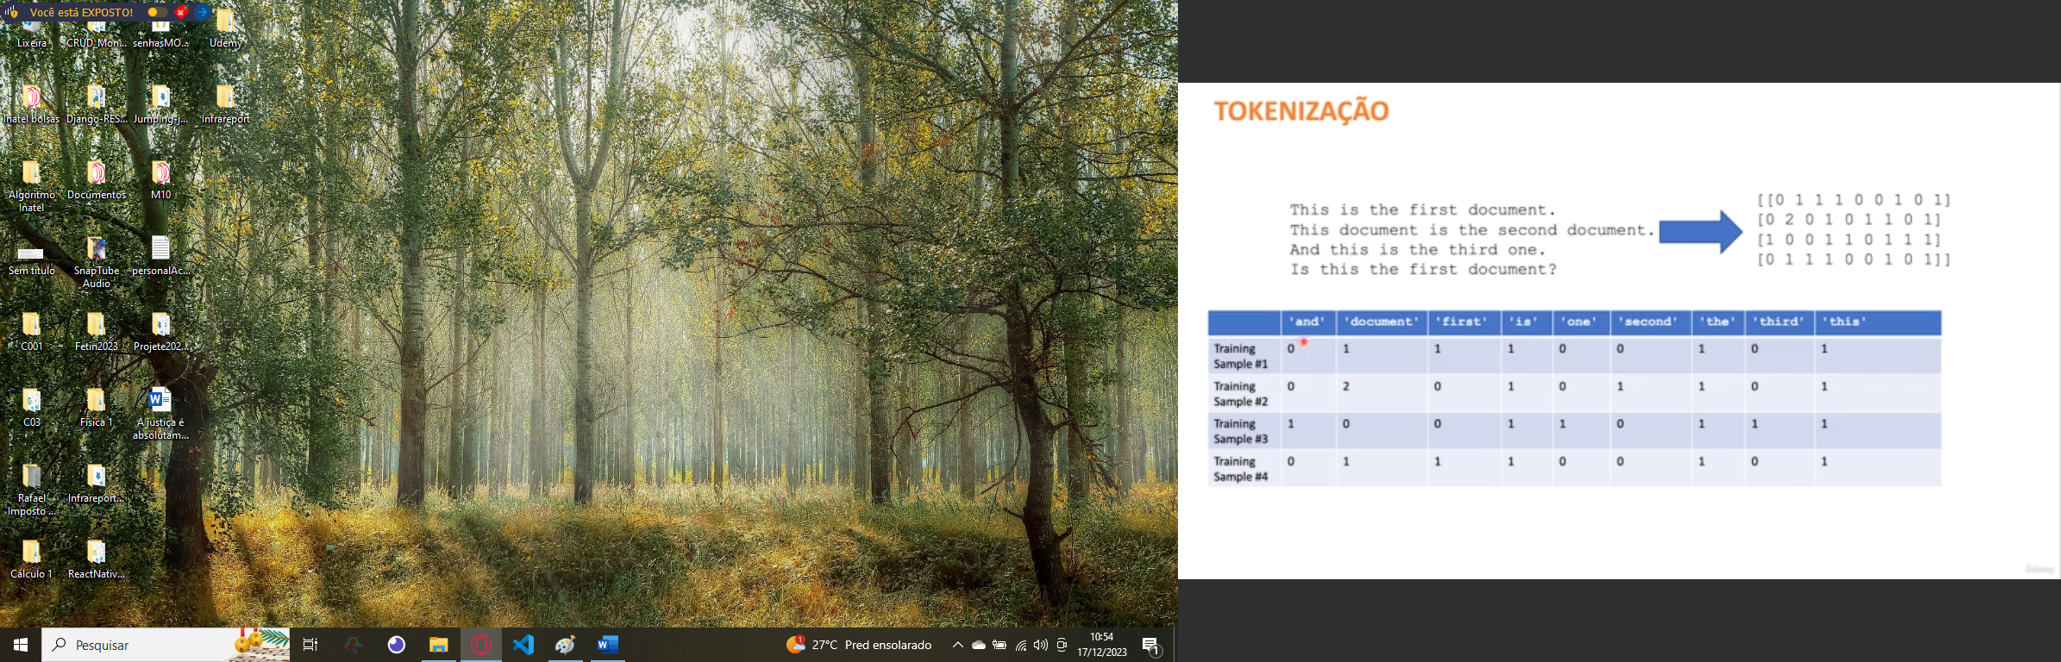

A ***Confusion Matrix*** is a table used in machine learning to evaluate the performance of a classification model. It allows a detailed understanding of how well a model is performing in terms of making predictions for different classes.

In a classification problem, where the goal is to predict the class or category of a given input (e.g., whether an email is spam or not, or whether an image contains a cat or a dog), a confusion matrix provides a summary of the model's performance by comparing the predicted classes against the actual classes.

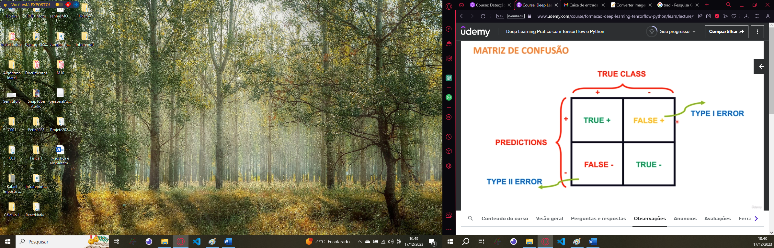

It consists of four main elements:

1. True Positives (TP): The number of instances correctly predicted as belonging to the positive class.
2. True Negatives (TN): The number of instances correctly predicted as belonging to the negative class.
3. False Positives (FP): The number of instances incorrectly predicted as belonging to the positive class when they actually belong to the negative class (Type I error).
4. False Negatives (FN): The number of instances incorrectly predicted as belonging to the negative class when they actually belong to the positive class (Type II error).

From these elements, various metrics can be derived to evaluate the model's performance, such as:

* Accuracy: The proportion of correct predictions among the total number of predictions.
* Precision: The proportion of true positive predictions among all positive predictions made by the model.
* Recall (Sensitivity or True Positive Rate): The proportion of true positive predictions among all actual positive instances.
* F1 Score: The harmonic mean of precision and recall, providing a balance between the two metrics.

